Page 1-6: Select - Player move
Page 7-9: Next move
Page 10: Undo
Page 11 Redo
Page 12-13: New Game
Page 14: Key Card

1. Test case : player moves
Game start, blue start (or red)
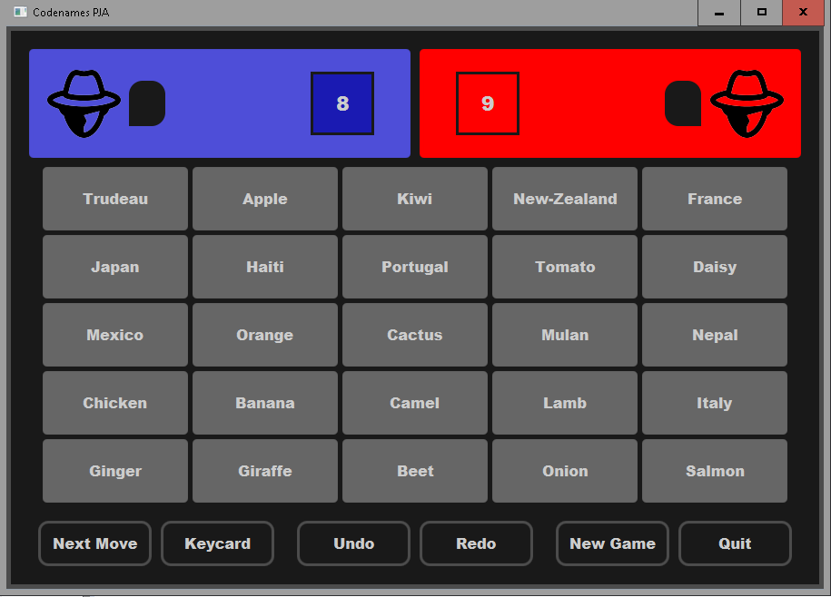Figure 1.1

Blue picks blue card -> updates number of card remaining for blue
Blue turn continues
(vice versa for red)
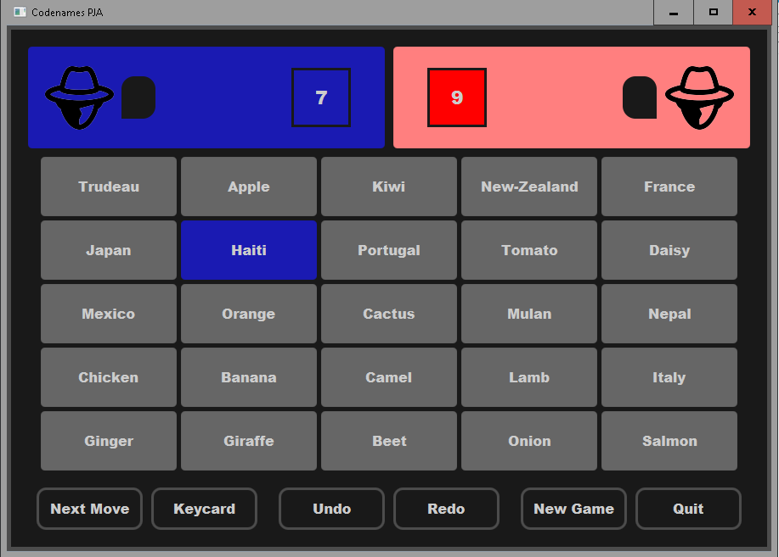
Figure 1.2

Blue picks blue card -> updates number of card remaining for blue
Blue turn continues
(vice versa for red)
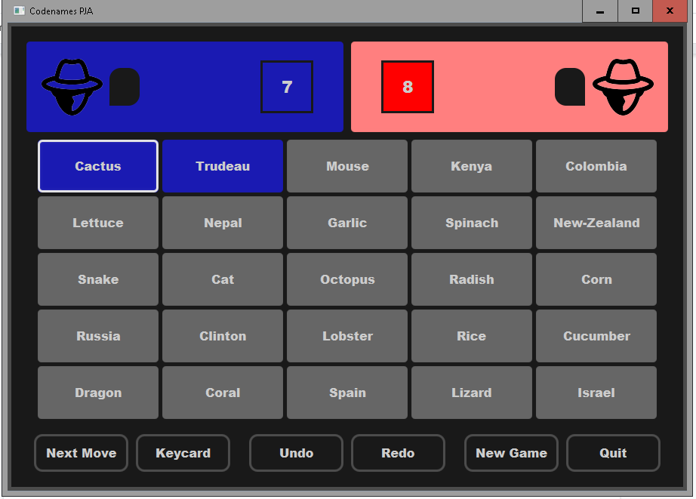
Figure 1.3

Blue picks card yellow -> number of cards blue unaffected
Blue turn ends, red turn to pick
(vice versa for red)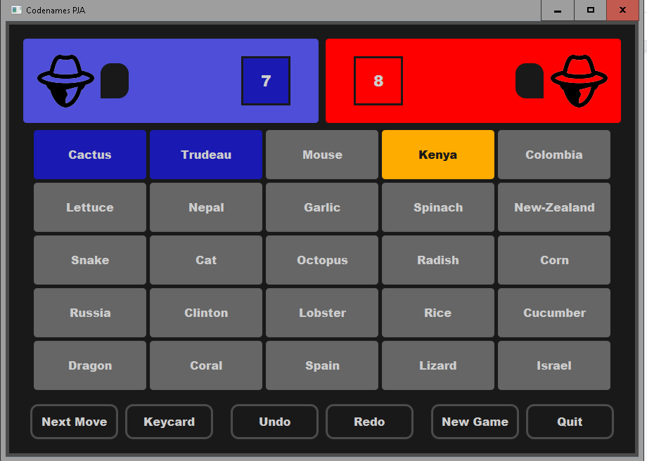
Figure 1.4

Blue picks card yellow -> number of cards blue unaffected, but red card is updated
Blue turn ends, red turn to pick
(vice versa for red)
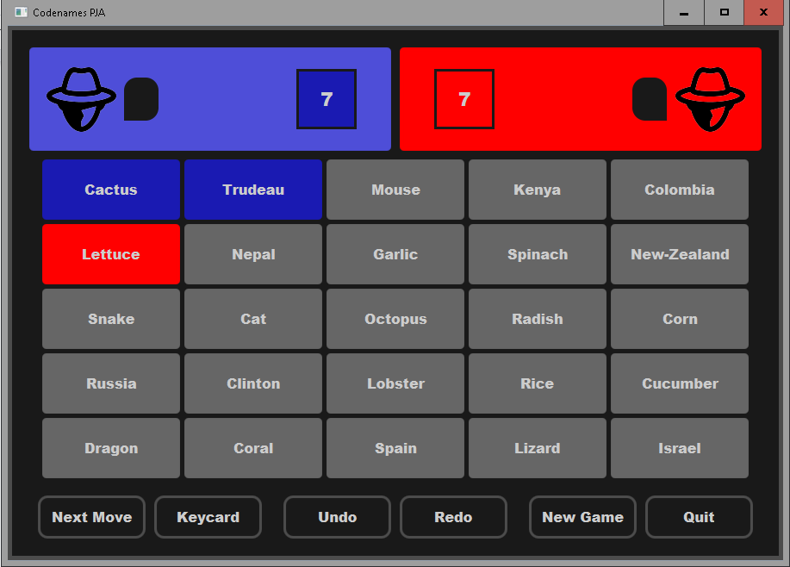Figure 1.5

Either red or blue picks black card => the opposite team wins
In the following, red picked black - blue wins
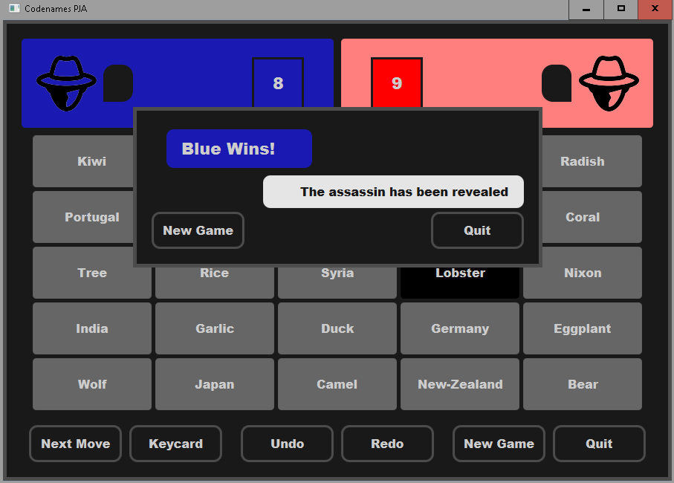Figure 1.6

2.Test case: Next move
Game start fig.1.1
Click Next Move - blue or red gets prompted a hint and picks a card
In the following, the blue player picked right, so count is updated.
It is still blue’s turn

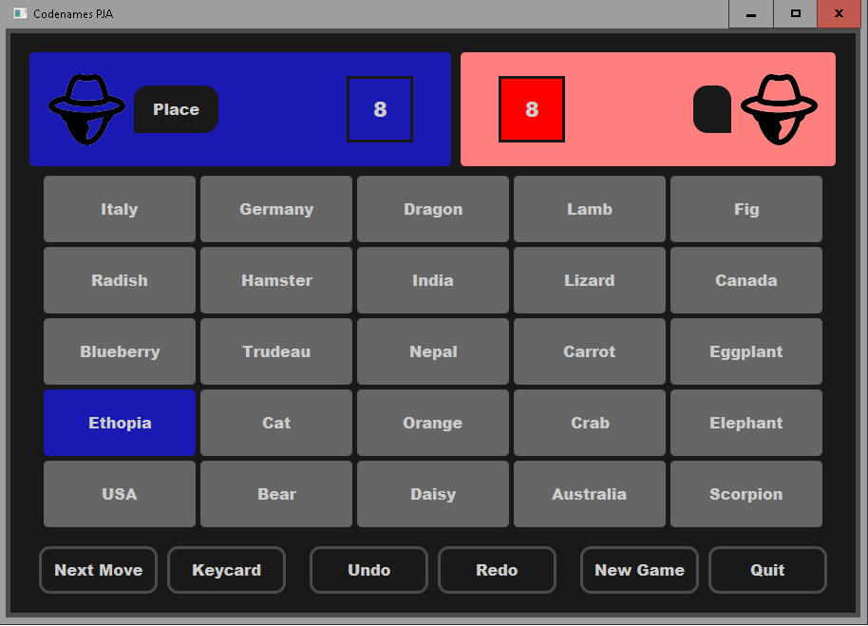Figure 2.1

Pick the wrong card (yellow or the opposite color) after pressing Next Move
Similar to figure 1.4, blue turn ends and it is red turn
Red gets a hint
Click Next move until game ends
Figure 2.1 and 2.1 will repeat
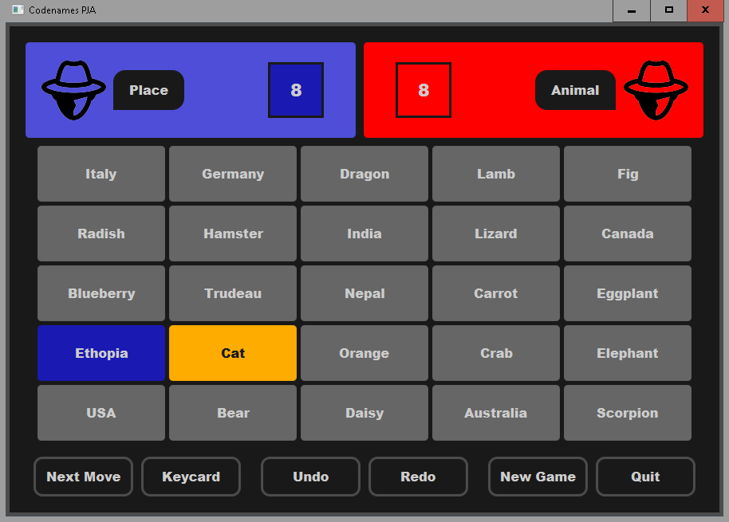Figure 2.2

Pressing Next move and the blue or red team picks wrong will be as Figure 1.6
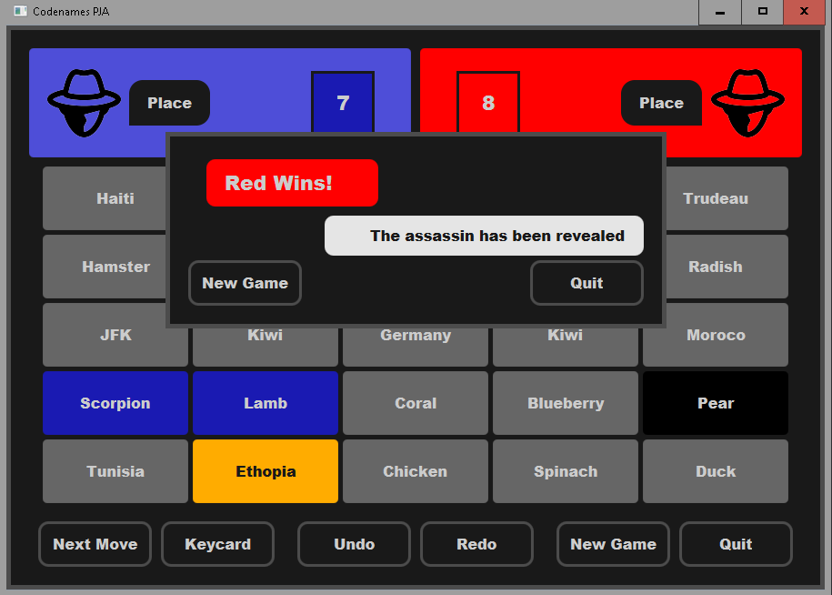
Figure 2.3

3. Test case: Undo
Pressing will undo the previous move (beef in this situation)

Before pressing undo:
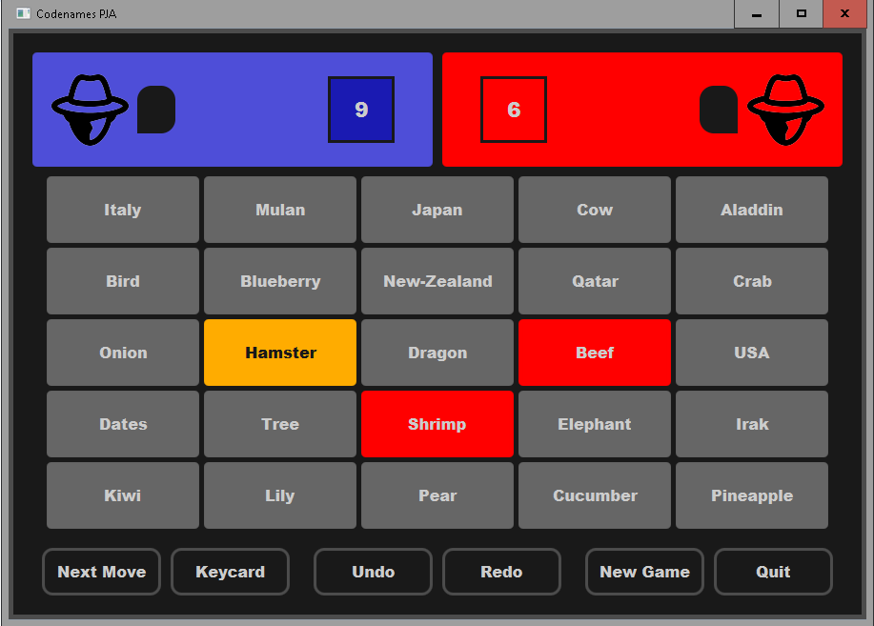
Figure 3.1

After pressing undo:
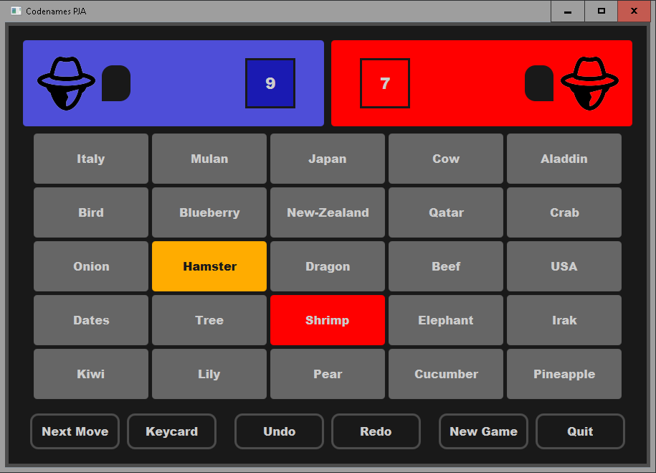
Figure 3.2

4. Test case: Redo
Pressing redo, will redo the undo move (in this situation beef)

Before pressing redo:
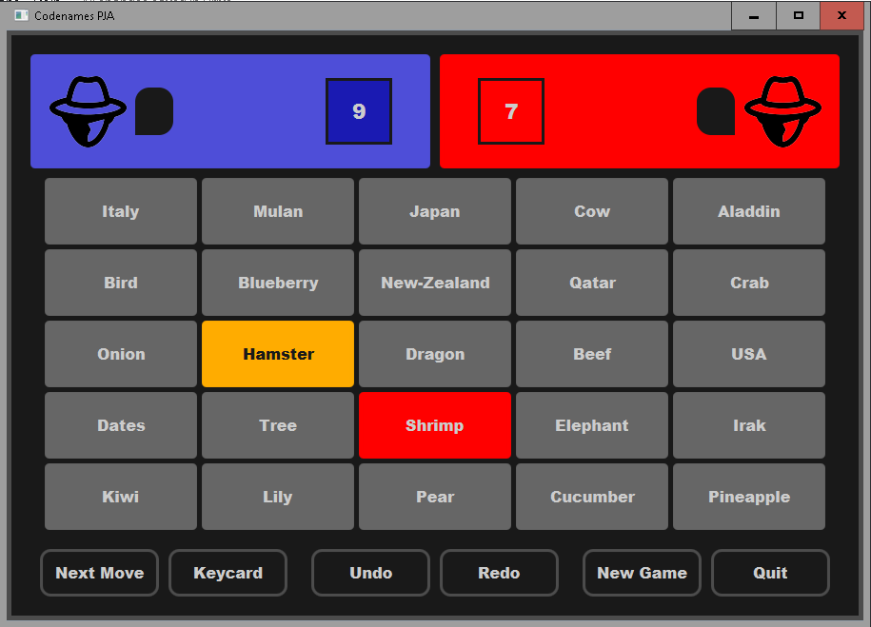
Figure 4.2

After pressing redo:
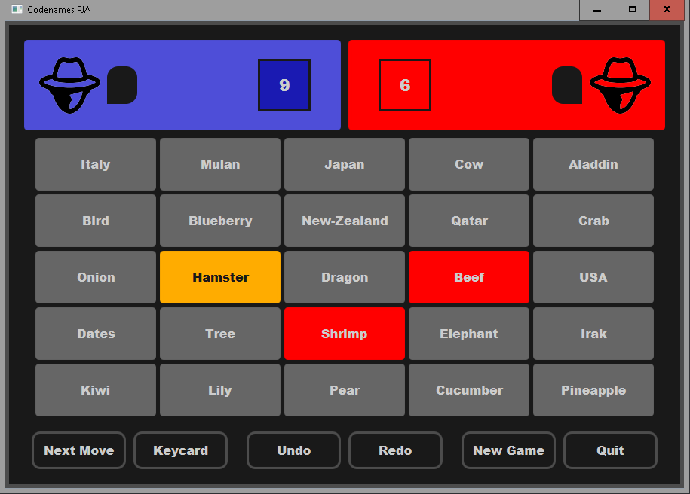
Figure 4.1

5.Test Case: New game
Pressing New game will prompt the following :
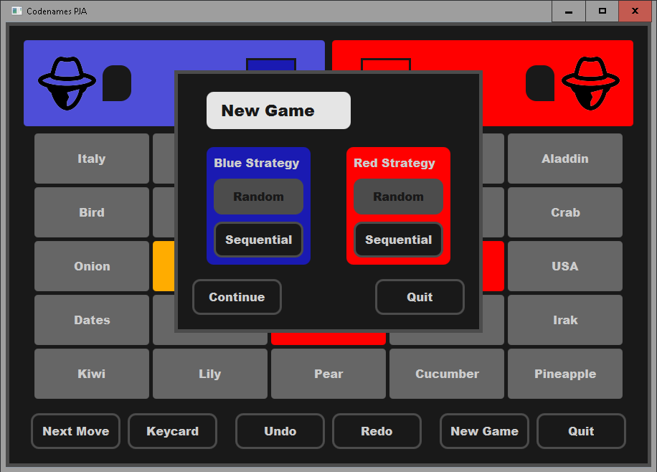
Figure 5.1

Pressing New Game will start a new Game
(Notice how the cards are different)
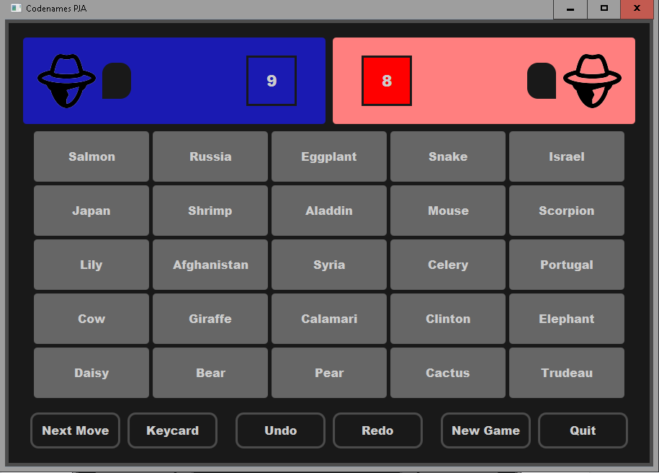
Figure 5.2

Picking Quit will exit/close the game

Figure 5.3

6. Test case: Pick card Keycard
Picking Keycard will prompt the Keycard of the game: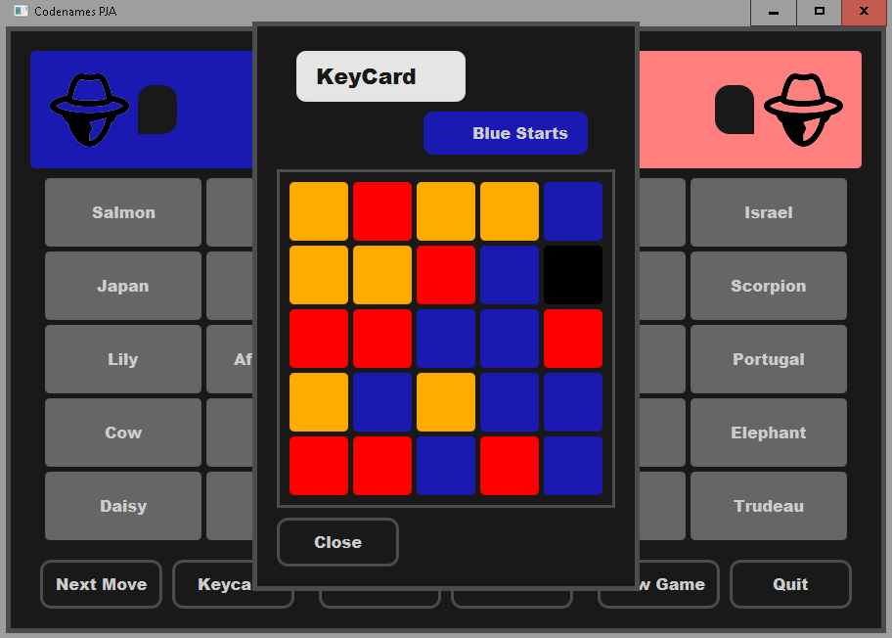
Figure 6.1

